Helping new mothers find their way
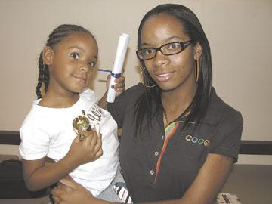
Tracy Agnew/Suffolk News-Herald Ebony Smith, right, and her daughter Samiya Smith, 5, graduated from the Healthy Families program on Tuesday. The program is designed to provide support for first-time mothers who volunteer for Healthy Families.

Tuesday, August 12, 2008 7:57 PM CDT

When Ebony Smith gave birth to her daughter, Samiya, when she was 17, she knew she would need some extra support.
When she heard about the Healthy Families program, she knew that was just what she needed.
The Healthy Families program is an initiative that helps new mothers - no matter their age, income or family status - to learn parenting skills that will set them on the right path of parenthood. Families can stay in the program up to the child entering kindergarten, during which time the family support workers help the mothers by doing home visits, developmental checks, connecting the mothers with community resources, and emphasizing the importance of safety, doctor visits, and reading to children when they are young.
Participation in the program is completely voluntary, and it does not cost the mothers anything.
When Ebony and Samiya Smith entered the program, Smith was still in high school and attending classes at the Pruden Center for PC technology. Smith said it is thanks to Healthy Families - and her own family - that she was able to graduate from high school and the Pruden Center, and continue on to receive her associate's degree in computer science from Paul D. Camp Community College. Healthy Families was able to connect her with financial aid resources so she could get her degree.
"She made sure Samiya was on the right path," Smith said of her family support worker, Cynthia Smith. "It helped me become a better mom."
Families who stay in the program until the child enters kindergarten graduate from the program. Seven mothers and their children, including Ebony and Samiya, were honored with a graduation ceremony Tuesday at Suffolk Christian Church. Smith now is a manager at Best Buy, and Samiya will enter kindergarten next month.
The two are one of the many success stories of Healthy Families, its leaders say.
Funded by the Obici Healthcare Foundation, state and city funds and in-kind donations, Healthy Families is in its 11th year. It currently serves Suffolk and Isle of Wight families, although they are looking to expand to Franklin and Southampton, said Beverly McQuarry, team supervisor for Healthy Families.
McQuarry said Ebony and Samiya Smith are a perfect example of the goals the program tries to achieve - Smith was able to continue her education with the help of the program, and Samiya is above her age level in many areas of development.
"That's the people you're doing it for," she said. "It's just moms that just need that little extra support."
Smith said she is glad she chose to participate in Healthy Families.
"I definitely recommend the program to any young mother," she said. "You definitely learn a lot from the program.
"Without the support of the program and my family, it wouldn't have been possible for me to get where I am."

